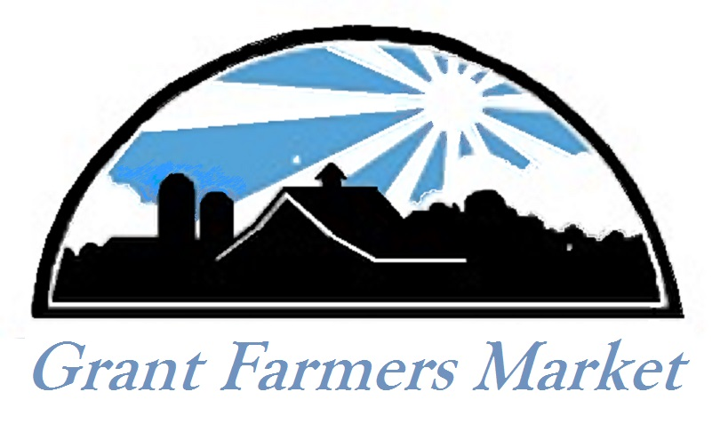

Farm Market Fun Day with
Rockin’ Newaygo County!
Come out for this
FREE Family Event
At the Grant Farmers Market
On Saturday, July 29
From 10 am until 2pm!
Paint Rocks, Be Groovy!
#RockinNC

